[**Buy and Sell Stocks With Cooldown | (DP – 39)**](https://takeuforward.org/data-structure/buy-and-sell-stocks-with-cooldown-dp-39/)

We are given an array Arr[] of length n. It represents the price of a stock on ‘n’ days. The following guidelines need to be followed:

1. We can [buy and sell the stock](https://takeuforward.org/data-structure/stock-buy-and-sell/) any number of times.
2. In order to sell the stock, we need to first buy it on the same or any previous day.
3. We can’t buy a stock again after buying it once. In other words, we first buy a stock and then sell it. After selling we can buy and sell again. But we can’t sell before buying and can’t buy before selling any previously bought stock.
4. We can’t buy a stock on the very next day of selling it. This is the **cooldown** clause.

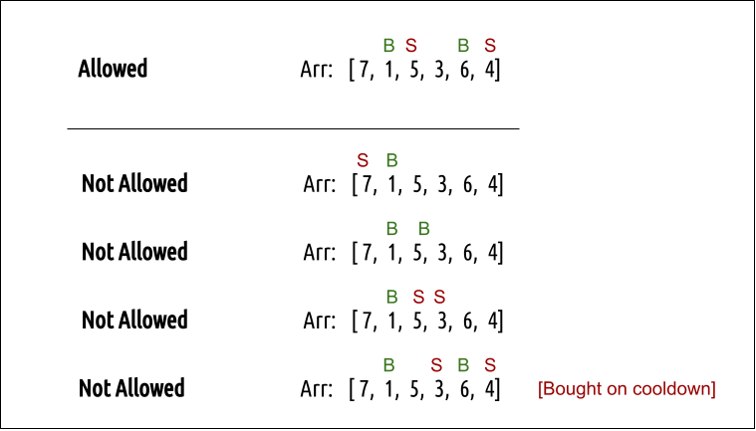

**Example:**

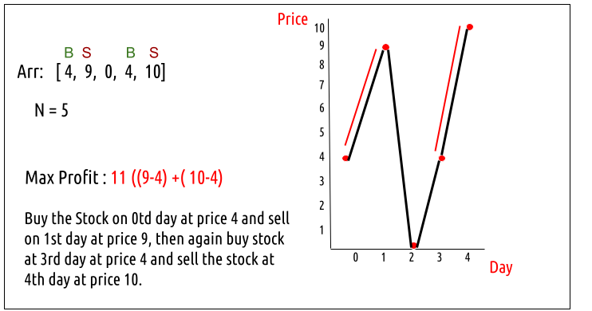

**Disclaimer**: Don’t jump directly to the solution, try it out yourself first.

### **Solution :**

### **Intuition:**

Every day, we will have two choices, either to do nothing and move to the next day or to buy/sell (based on the last transaction and whether we are on a cooldown day or not) and find out the profit. Therefore we need to generate all the choices in order to compare the profit. As we need to try out all the possible choices, we will use **recursion**.

**Steps to form the recursive solution:**

We will first form the recursive solution by the three points mentioned in the [Dynamic Programming Introduction](https://takeuforward.org/data-structure/dynamic-programming-introduction/).

**Step 1:**Express the problem in terms of indexes.

We need to think in the terms of the number of days, therefore one variable will be the array index( say ind). Next, we need to respect the condition that we can’t buy a stock again, that is we need to first sell a stock, and then we can buy that again. Therefore we need a second variable ‘buy’ which tells us on a particular day whether we can buy or sell the stock. We can generalize the function as :

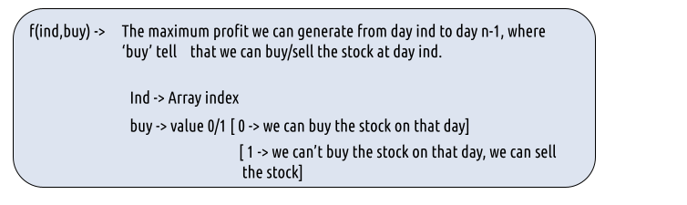

**Step 2:**Try out all possible choices at a given index.

Every day, we have two choices:

* To either buy/sell the stock(based on the buy variable’s value).
* To do nothing and move on to the next day.

We need to generate all the choices. We will use the pick/non-pick technique as discussed in this video “[Recursion on Subsequences](https://www.youtube.com/watch?v=AxNNVECce8c)”.

**Case 1:**When buy == 0, we can buy the stock.

If we can buy the stock on a particular day, we have two options:

* **Option 1:**To do no transaction and move to the next day. In this case, the net profit earned will be **0** from the current transaction, and to calculate the maximum profit starting from the next day, we will recursively call f(ind+1,0). As we have not bought the stock, the ‘buy’ variable value will still remain 0, indicating that we can buy the stock the next day.
* **Option 2:**The other option is to buy the stock on the current day. In this case, the net profit earned from the current transaction will be **-Arr[i]**. As we are buying the stock, we are giving money out of our pocket, therefore the profit we earn **is negative**. To calculate the maximum profit starting from the next day, we will recursively call f(ind+1,1). As we have bought the stock, the ‘buy’ variable value will change to 1, indicating that we can’t buy and only sell the stock the next day.

**Case 2:**When buy == 1, we can sell the stock.

If we can buy the stock on a particular day, we have two options:

* **Option 1:**To do no transaction and move to the next day. In this case, the net profit earned will be **0** from the current transaction, and to calculate the maximum profit starting from the next day, we will recursively call f(ind+1,1). As we have not bought the stock, the ‘buy’ variable value will still remain at 1, indicating that we can’t buy and only sell the stock the next day.
* **Option 2:**The other option is to sell the stock on the current day. In this case, the net profit earned from the current transaction will be +**Arr[i]**. As we are selling the stock, we are putting the money into our pocket, therefore the profit we earn **is positive**. When we sell a stock on day **ind**, we can’t buy it on day ind+1 ( according to the **cooldown** clause) therefore we simply skip that day and find the profit starting from day ind+2, therefore we recursively call **f(ind+2,0)**.

The figure below gives us the summary:

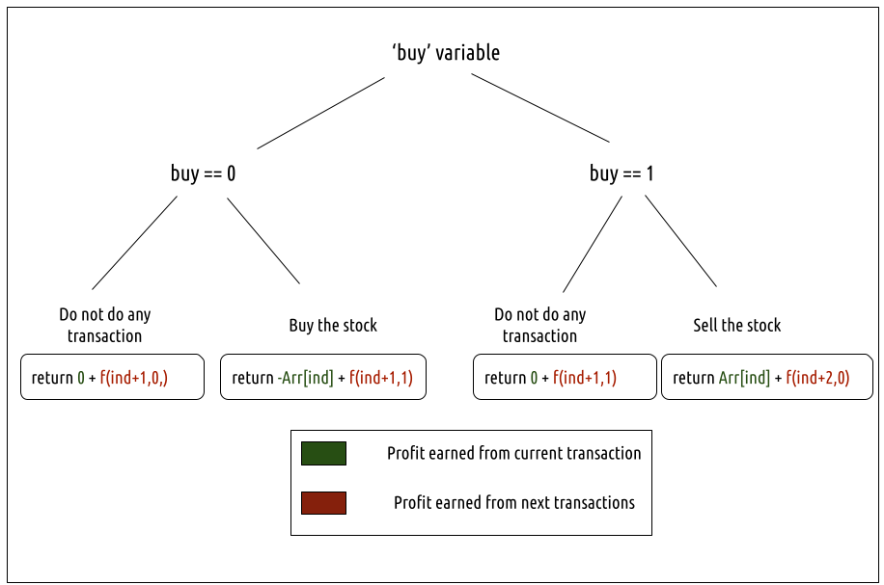

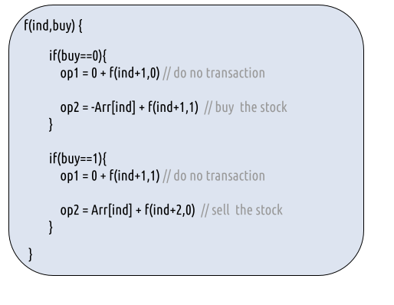

**Step 3:  Return the maximum**

As we are looking to maximize the profit earned, we will return the maximum value in both cases.

The final pseudocode after steps 1, 2, and 3:

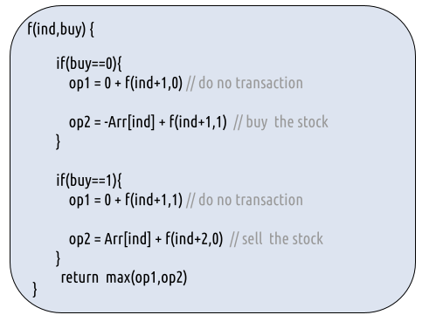

**Base Cases:**

* If ind>=n, it means we have finished trading on all days, and there is no more money that we can get, therefore we simply return 0.  When ind=n-1, it can happen that we call f(ind+2,0), therefore we have handled this edge case by using the “>=” sign.

**Steps to memoize a recursive solution:**

If we draw the recursion tree, we will see that there are overlapping subproblems. In order to convert a recursive solution the following steps will be taken:

1. Create a dp array of size [n][2]. The size of the input array is ‘n’, so the index will always lie between ‘0’ and ‘n-1’. The ‘buy’  variable can take only two values: 0 and 1. Therefore we take the dp array as dp[n][2]
2. We initialize the dp array to -1.
3. Whenever we want to find the answer to particular parameters (say f(ind, buy)), we first check whether the answer is already calculated using the dp array(i.e dp[ind][buy]!= -1 ). If yes, simply return the value from the dp array.
4. If not, then we are finding the answer for the given value for the first time, we will use the recursive relation as usual but before returning from the function, we will set dp[ind][buy] to the solution we get.

**Code:**

* C++ Code
* Java Code

#include <bits/stdc++.h>

using namespace std;

int getAns(vector<int> Arr, int ind, int buy, int n, vector<vector<int>> &dp ){

if(ind>=n) return 0; //base case

if(dp[ind][buy]!=-1)

return dp[ind][buy];

int profit;

if(buy==0){// We can buy the stock

profit = max(0+getAns(Arr,ind+1,0,n,dp), -Arr[ind]+getAns(Arr,ind+1,1,n,dp));

}

if(buy==1){// We can sell the stock

profit = max(0+getAns(Arr,ind+1,1,n,dp), Arr[ind]+getAns(Arr,ind+2,0,n,dp));

}

return dp[ind][buy] = profit;

}

int stockProfit(vector<int> &Arr)

{

int n = Arr.size();

vector<vector<int>> dp(n,vector<int>(2,-1));

int ans = getAns(Arr,0,0,n,dp);

return ans;

}

int main() {

vector<int> prices {4,9,0,4,10};

cout<<"The maximum profit that can be generated is "<<stockProfit(prices);

}

**Output:**

The maximum profit that can be generated is 11

**Time Complexity: O(N*2)**

Reason: There are N*2 states therefore at max ‘N*2’ new problems will be solved and we are running a for loop for ‘N’ times to [calculate the total sum](https://takeuforward.org/arrays/calculate-sum-of-the-elements-of-the-array/)

**Space Complexity: O(N*2) + O(N)**

Reason: We are using a recursion stack space(O(N)) and a 2D array ( O(N*2)).

**Steps to convert Recursive Solution to Tabulation one.**

To convert the memoization approach to a tabulation one, create a dp array with the same size as done in memoization. We can set its type as bool and initialize it as false.

* First, we declare the dp array of size [n+1][2] as zero.
* Next, we set the base condition, we set dp[n][0] = dp[n][1] = 0(the case when we had exhausted the number of days of the stock market).

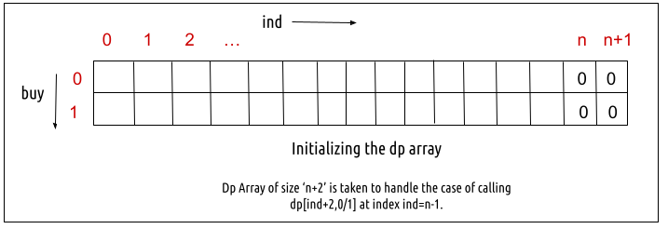

* Next, we set two nested for loops, the outer loop (for variable ind) moves from  n-1 to 0 and the inner loop (for variable buy) moves from 0 to 1.

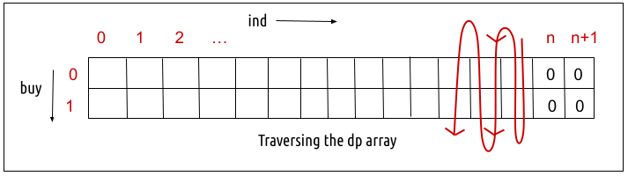

* In every iteration, we calculate the value according to the memoization logic.
* At last, we will print dp[0][0] as our answer.

**Code:**

* C++ Code
* Java Code

#include <bits/stdc++.h>

using namespace std;

int stockProfit(vector<int> &Arr)

{

int n = Arr.size();

vector<vector<int>> dp(n+2,vector<int>(2,0));

for(int ind = n-1; ind>=0; ind--){

for(int buy=0; buy<=1; buy++){

int profit;

if(buy==0){// We can buy the stock

profit = max(0+dp[ind+1][0], -Arr[ind] + dp[ind+1][1]);

}

if(buy==1){// We can sell the stock

profit = max(0+dp[ind+1][1], Arr[ind] + dp[ind+2][0]);

}

dp[ind][buy] = profit;

}

}

return dp[0][0];

}

int main() {

vector<int> prices {4,9,0,4,10};

cout<<"The maximum profit that can be generated is "<<stockProfit(prices);

}

**Output:**

The maximum profit that can be generated is 11

**Time Complexity: O(N*2)**

Reason: There are two nested loops that account for O(N*2) complexity.

**Space Complexity: O(N*2)**

Reason: We are using an external array of size ‘N*2’. Stack Space is eliminated.

**Part 3: Space Optimization**

If we closely look the relation,

**dp[ind][buy] = max( dp[ind+1][buy] , max( dp[ind+2][!buy])**

We see that to calculate a value of a cell of the dp array, we need only the next two column values(say front1 and front2). So, we don’t need to store an entire 2-D array. Hence we can space optimize it.

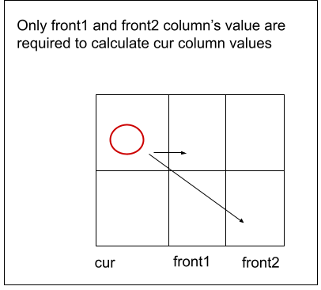

* We set the front1 and front2 columns as 0 (base condition)
* Then we set the nested loops to calculate the cur column values.
* We replace dp[ind] with cur and dp[ind+1] with front1 and dp[ind+2] with front2 in our memoization code.
* After the inner loop execution, we set ahead as cur for the next outer loop iteration.
* At last, we return cur[0] as our answer.

**Code:**

* C++ Code
* Java Code

#include <bits/stdc++.h>

using namespace std;

int stockProfit(vector<int> &Arr)

{

int n = Arr.size();

vector<int> cur(2,0);

vector<int> front1(2,0);

vector<int> front2(2,0);

for(int ind = n-1; ind>=0; ind--){

for(int buy=0; buy<=1; buy++){

int profit;

if(buy==0){// We can buy the stock

profit = max(0+front1[0], -Arr[ind] + front1[1]);

}

if(buy==1){// We can sell the stock

profit = max(0+front1[1], Arr[ind] + front2[0]);

}

cur[buy] = profit;

}

front2 = front1;

front1 = cur;

}

return cur[0];

}

int main() {

vector<int> prices {4,9,0,4,10};

cout<<"The maximum profit that can be generated is "<<stockProfit(prices);

}

**Output:**

The maximum profit that can be generated is 11

**Time Complexity: O(N*2)**

Reason: There are two nested loops that account for O(N*2) complexity

**Space Complexity: O(1)**

Reason: We are using three external arrays of size ‘2’.